
Koneru Lakshmaiah Education Foundation
(Deemed to be University estd. u/s. 3 of the UGC Act, 1956)
Off-Campus: Bachupally-Gandimaisamma Road, Bowrampet, Hyderabad, Telangana - 500 043. Phone No: 7815926816, www.klh.edu.in

STUDENT CASE STUDY EXECUTION REPORT
Department | FED
Subject | DSA-2
Academic Year | 1-111 Semester | 2025-26
Faculty Name | Dr. Lahari Gollamudi
Student Name | B. Sree Niharika
Roll Number | 2520030589
Branch | CSE
Course Outcome | CO 3
Case Study Topic: Attendance Device Network Planning using BFS, DFS, Kruskal's and Prim's Algorithms
Work Done Summary:
In this case study, we designed a network for connecting biometric attendance devices installed across different blocks of a college campus. Graph algorithms were used to analyze connectivity and minimize network installation cost.
- BFS was used to traverse all attendance devices level by level from the main server.
- DFS was used to explore all possible device connections deeply.
- Kruskal's Algorithm was applied to find the Minimum Spanning Tree (MST) with minimum cable cost.
- Prim's Algorithm was used to construct an optimized attendance device network from a selected starting point.
- The final network ensured complete connectivity with reduced installation cost.

Implementation Details:
1 Represented attendance devices and server as graph vertices.
2 Applied BFS to verify device reachability from the central server.
3 Applied DFS to explore complete network connectivity.
4 Calculated cable costs between attendance devices.
5 Implemented Kruskal's Algorithm to generate a Minimum Spanning Tree.
6 Implemented Prim's Algorithm for alternative MST construction.
7 Compared total network costs obtained from both MST algorithms.
• Compared total network costs obtained from both MST algorithms. 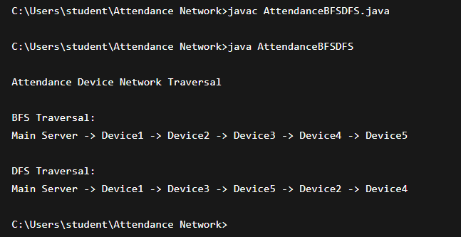

Result: Screenshots / Output

BFS Traversal:
Server → Device A → Device B → Device C → Device D → Device E
DFS Traversal:
Server → Device A → Device C → Device E → Device B → Device D
Kruskal's MST Cost:
Total Network Cost = 42 Units
Prim's MST Cost:
Total Network Cost = 42 Units

Time Complexity:
• BFS Traversal: O(V + E)
• DFS Traversal: O(V + E)
• Kruskal's Algorithm: O(E log E)
• Prim's Algorithm: O(E log V)

BFS and DFS successfully verified connectivity among attendance devices. Kruskal's and Prim's Algorithms generated the Minimum Spanning Tree with the least network installation cost. The optimized network reduced cabling expenses while maintaining complete communication between all attendance devices and the central server.

GitHub Link:
Student Signature Faculty Signature

